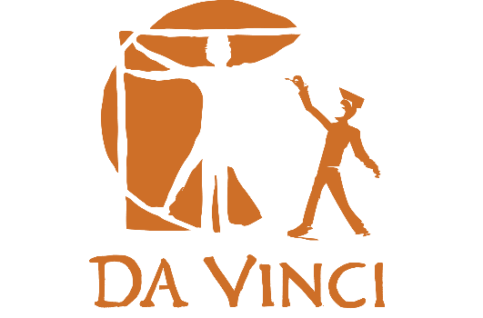
Fall 2017 DVD/DVC Community College Course Opportunities

Who: Juniors and seniors from DVC and DVD
What: College courses at Da Vinci, through El Camino and West. L.A. Community Colleges. Courses meet transfer requirements for all Cal State and U.C. campuses, as well as most private colleges and universities.
Why: Get a jump on your college credits! If you do well, it also looks great on your college applications.
Cost: Free! The state of California and Da Vinci Schools pick up the costs, including text book fees. Donations to help cover the cost of the textbooks for families that are able are appreciated.
Where: Classes will be held on the Da Vinci campus in Del Aire until the move to the new building at 201 N. Douglas

Music 111 – Music Appreciation | Ethnic Studies 1 – Intro to Ethnic Studies
West Los Angeles College  Tuesdays and Thursdays 3:00-4:35 | El Camino College  Mondays and Wednesday 3:00-5:15

If you are interested please see your college counselor to sign up. Please note that these are college courses, taught by college instructors. All students must show their counselor and administrators the academic skills and accountability necessary to be in these courses. Students must abide by the college policies, including regarding absences and tardies.

